Chacha20

Encryption Time Computation: 79 microsecond (μs)

Plaintext Data: Hello ESP-8266!!!

Plaintext Size: 17

Encrypted Data: 58 94 8B 88 BE 1B 1C 46 0 22 E5 2D 95 16 50 E5 E6

Encryption Time Computation: 80 microsecond (μs)

Plaintext Data: Hello ESP-8266!!!

Plaintext Size: 17

Encrypted Data: 58 94 8B 88 BE 1B 1C 46 0 22 E5 2D 95 16 50 E5 E6

Encryption Time Computation: 80 microsecond (μs)

Plaintext Data: Hello ESP-8266!!!

Plaintext Size: 17

Encrypted Data: 58 94 8B 88 BE 1B 1C 46 0 22 E5 2D 95 16 50 E5 E6

Encryption Time Computation: 79 microsecond (μs)

Plaintext Data: Hello ESP-8266!!!

Plaintext Size: 17

Encrypted Data: 58 94 8B 88 BE 1B 1C 46 0 22 E5 2D 95 16 50 E5 E6

Encryption Time Computation: 79 microsecond (μs)

Plaintext Data: Hello ESP-8266!!!

Plaintext Size: 17

Encrypted Data: 58 94 8B 88 BE 1B 1C 46 0 22 E5 2D 95 16 50 E5 E6

Encryption Time Computation: 79 microsecond (μs)

Plaintext Data: Hello ESP-8266!!!

Plaintext Size: 17

Encrypted Data: 58 94 8B 88 BE 1B 1C 46 0 22 E5 2D 95 16 50 E5 E6

Encryption Time Computation: 79 microsecond (μs)

Plaintext Data: Hello ESP-8266!!!

Plaintext Size: 17

Encrypted Data: 58 94 8B 88 BE 1B 1C 46 0 22 E5 2D 95 16 50 E5 E6

Encryption Time Computation: 79 microsecond (μs)

Plaintext Data: Hello ESP-8266!!!

Plaintext Size: 17

Encrypted Data: 58 94 8B 88 BE 1B 1C 46 0 22 E5 2D 95 16 50 E5 E6

Encryption Time Computation: 79 microsecond (μs)

Plaintext Data: Hello ESP-8266!!!

Plaintext Size: 17

Encrypted Data: 58 94 8B 88 BE 1B 1C 46 0 22 E5 2D 95 16 50 E5 E6

Encryption Time Computation: 80 microsecond (μs)

79x7 dan 80x3 = 793/10

rata-rata waktu komputasi = 79.3 microsecond (μs)

AES256

23:09:36.284 -> Encrypted Data (Hex): 22 14 07 47 C0 C9 7F 5C 6C 2A 25 02 34 17 B6 4E CA EF 67 5B CE 76 92 4D 1D 7A A7 0D C1 B1 5F 34

23:09:36.330 -> Encryption Time Computation: 400 microsecond (μs)

23:09:37.281 -> Original Data: Hello ESP-8266!!!

23:09:37.326 -> Plaintext Size: 17

23:09:37.326 -> Encrypted Data (Hex): 22 14 07 47 C0 C9 7F 5C 6C 2A 25 02 34 17 B6 4E CA EF 67 5B CE 76 92 4D 1D 7A A7 0D C1 B1 5F 34

23:09:37.326 -> Encryption Time Computation: 401 microsecond (μs)

23:09:38.290 -> Original Data: Hello ESP-8266!!!

23:09:38.336 -> Plaintext Size: 17

23:09:38.336 -> Encrypted Data (Hex): 22 14 07 47 C0 C9 7F 5C 6C 2A 25 02 34 17 B6 4E CA EF 67 5B CE 76 92 4D 1D 7A A7 0D C1 B1 5F 34

23:09:38.336 -> Encryption Time Computation: 400 microsecond (μs)

23:09:39.334 -> Original Data: Hello ESP-8266!!!

23:09:39.334 -> Plaintext Size: 17

23:09:39.334 -> Encrypted Data (Hex): 22 14 07 47 C0 C9 7F 5C 6C 2A 25 02 34 17 B6 4E CA EF 67 5B CE 76 92 4D 1D 7A A7 0D C1 B1 5F 34

23:09:39.334 -> Encryption Time Computation: 401 microsecond (μs)

23:09:40.319 -> Original Data: Hello ESP-8266!!!

23:09:40.319 -> Plaintext Size: 17

23:09:40.319 -> Encrypted Data (Hex): 22 14 07 47 C0 C9 7F 5C 6C 2A 25 02 34 17 B6 4E CA EF 67 5B CE 76 92 4D 1D 7A A7 0D C1 B1 5F 34

23:09:40.363 -> Encryption Time Computation: 401 microsecond (μs)

23:09:41.361 -> Original Data: Hello ESP-8266!!!

23:09:41.361 -> Plaintext Size: 17

23:09:41.361 -> Encrypted Data (Hex): 22 14 07 47 C0 C9 7F 5C 6C 2A 25 02 34 17 B6 4E CA EF 67 5B CE 76 92 4D 1D 7A A7 0D C1 B1 5F 34

23:09:41.361 -> Encryption Time Computation: 400 microsecond (μs)

23:09:42.360 -> Original Data: Hello ESP-8266!!!

23:09:42.360 -> Encrypted Data (Hex): 22 14 07 47 C0 C9 7F 5C 6C 2A 25 02 34 17 B6 4E CA EF 67 5B CE 76 92 4D 1D 7A A7 0D C1 B1 5F 34

23:09:42.360 -> Encryption Time Computation: 401 microsecond (μs)

23:09:43.373 -> Original Data: Hello ESP-8266!!!

23:09:43.373 -> Plaintext Size: 17

23:09:43.373 -> Encrypted Data (Hex): 22 14 07 47 C0 C9 7F 5C 6C 2A 25 02 34 17 B6 4E CA EF 67 5B CE 76 92 4D 1D 7A A7 0D C1 B1 5F 34

23:09:43.373 -> Encryption Time Computation: 401 microsecond (μs)

23:09:44.380 -> Original Data: Hello ESP-8266!!!

23:09:44.380 -> Plaintext Size: 17

23:09:44.380 -> Encrypted Data (Hex): 22 14 07 47 C0 C9 7F 5C 6C 2A 25 02 34 17 B6 4E CA EF 67 5B CE 76 92 4D 1D 7A A7 0D C1 B1 5F 34

23:09:44.380 -> Encryption Time Computation: 402 microsecond (μs)

23:09:45.391 -> Original Data: Hello ESP-8266!!!

23:09:45.391 -> Plaintext Size: 17

23:09:45.391 -> Encrypted Data (Hex): 22 14 07 47 C0 C9 7F 5C 6C 2A 25 02 34 17 B6 4E CA EF 67 5B CE 76 92 4D 1D 7A A7 0D C1 B1 5F 34

23:09:45.391 -> Encryption Time Computation: 401 microsecond (μs)

23:09:46.401 -> Original Data: Hello ESP-8266!!!

23:09:46.401 -> Plaintext Size: 17

23:09:46.401 -> Encrypted Data (Hex): 22 14 07 47 C0 C9 7F 5C 6C 2A 25 02 34 17 B6 4E CA EF 67 5B CE 76 92 4D 1D 7A A7 0D C1 B1 5F 34

23:09:46.401 -> Encryption Time Computation: 401 microsecond (μs)

400X3 + 402X1 + 401X6

rata-rata waktu komputasi = 400,8 microsecond (μs)

Snow-V

01:38:20.227 -> Original Data: Hello ESP-8266!!!

01:38:20.227 -> Plaintext Size: 17

01:38:20.227 -> Encrypted Data: 57 78 73 71 D8 2A FC 6F 34 72 A8 C8 53 DA B 1B 42

01:38:20.227 -> Encryption Time Computation: 175 mikrosecond (μs)

01:38:20.227 -> ------------------------------------------------------

01:38:21.238 -> Original Data: Hello ESP-8266!!!

01:38:21.238 -> Plaintext Size: 17

01:38:21.238 -> Encrypted Data: 57 78 73 71 D8 2A FC 6F 34 72 A8 C8 53 DA B 1B 42

01:38:21.238 -> Encryption Time Computation: 175 mikrosecond (μs)

01:38:21.238 -> ------------------------------------------------------

01:38:22.219 -> Original Data: Hello ESP-8266!!!

01:38:22.219 -> Plaintext Size: 17

01:38:22.219 -> Encrypted Data: 57 78 73 71 D8 2A FC 6F 34 72 A8 C8 53 DA B 1B 42

01:38:22.219 -> Encryption Time Computation: 175 mikrosecond (μs)

01:38:22.264 -> ------------------------------------------------------

01:38:23.262 -> Original Data: Hello ESP-8266!!!

01:38:23.262 -> Plaintext Size: 17

01:38:23.262 -> Encrypted Data: 57 78 73 71 D8 2A FC 6F 34 72 A8 C8 53 DA B 1B 42

01:38:23.262 -> Encryption Time Computation: 175 mikrosecond (μs)

01:38:23.262 -> ------------------------------------------------------

01:38:24.273 -> Original Data: Hello ESP-8266!!!

01:38:24.273 -> Plaintext Size: 17

01:38:24.273 -> Encrypted Data: 57 78 73 71 D8 2A FC 6F 34 72 A8 C8 53 DA B 1B 42

01:38:24.273 -> Encryption Time Computation: 180 mikrosecond (μs)

01:38:24.273 -> ------------------------------------------------------

01:38:25.268 -> Original Data: Hello ESP-8266!!!

01:38:25.268 -> Plaintext Size: 17

01:38:25.268 -> Encrypted Data: 57 78 73 71 D8 2A FC 6F 34 72 A8 C8 53 DA B 1B 42

01:38:25.268 -> Encryption Time Computation: 176 mikrosecond (μs)

01:38:25.268 -> ------------------------------------------------------

01:38:26.252 -> Original Data: Hello ESP-8266!!!

01:38:26.252 -> Plaintext Size: 17

01:38:26.252 -> Encrypted Data: 57 78 73 71 D8 2A FC 6F 34 72 A8 C8 53 DA B 1B 42

01:38:26.295 -> Encryption Time Computation: 176 mikrosecond (μs)

01:38:26.295 -> ------------------------------------------------------

01:38:27.264 -> Original Data: Hello ESP-8266!!!

01:38:27.264 -> Plaintext Size: 17

01:38:27.264 -> Encrypted Data: 57 78 73 71 D8 2A FC 6F 34 72 A8 C8 53 DA B 1B 42

01:38:27.264 -> Encryption Time Computation: 176 mikrosecond (μs)

01:38:27.308 -> ------------------------------------------------------

01:38:28.275 -> Original Data: Hello ESP-8266!!!

01:38:28.275 -> Plaintext Size: 17

01:38:28.275 -> Encrypted Data: 57 78 73 71 D8 2A FC 6F 34 72 A8 C8 53 DA B 1B 42

01:38:28.275 -> Encryption Time Computation: 176 mikrosecond (μs)

01:38:28.322 -> ------------------------------------------------------

01:38:29.289 -> Original Data: Hello ESP-8266!!!

01:38:29.289 -> Plaintext Size: 17

01:38:29.289 -> Encrypted Data: 57 78 73 71 D8 2A FC 6F 34 72 A8 C8 53 DA B 1B 42

01:38:29.289 -> Encryption Time Computation: 176 mikrosecond (μs)

01:38:29.289 -> ------------------------------------------------------

175x4 +176x5 + 180x1 = 1760 / 10

rata-rata waktu komputasi = 176 microsecond (μs)

clefia256

02:29:58.580 -> Original Message Size: 16

02:29:58.580 -> Encrypted Message: 13 28 78 E0 47 FF B1 79 D1 FB 41 0D 14 BF F2 C1

02:29:58.580 -> Encryption Time (microseconds): 346

02:29:58.580 -> ----------------------------------------

02:29:59.562 -> Original Message: Hello ESP-8266!

02:29:59.562 -> Original Message Size: 16

02:29:59.562 -> Encrypted Message: 13 28 78 E0 47 FF B1 79 D1 FB 41 0D 14 BF F2 C1

02:29:59.606 -> Encryption Time (microseconds): 345

02:29:59.606 -> ----------------------------------------

02:30:00.602 -> Original Message: Hello ESP-8266!

02:30:00.602 -> Original Message Size: 16

02:30:00.602 -> Encrypted Message: 13 28 78 E0 47 FF B1 79 D1 FB 41 0D 14 BF F2 C1

02:30:00.602 -> Encryption Time (microseconds): 345

02:30:00.602 -> ----------------------------------------

02:30:01.615 -> Original Message: Hello ESP-8266!

02:30:01.615 -> Original Message Size: 16

02:30:01.615 -> Encrypted Message: 13 28 78 E0 47 FF B1 79 D1 FB 41 0D 14 BF F2 C1

02:30:01.615 -> Encryption Time (microseconds): 346

02:30:01.615 -> ----------------------------------------

02:30:02.621 -> Original Message: Hello ESP-8266!

02:30:02.621 -> Original Message Size: 16

02:30:02.621 -> Encrypted Message: 13 28 78 E0 47 FF B1 79 D1 FB 41 0D 14 BF F2 C1

02:30:02.621 -> Encryption Time (microseconds): 346

02:30:02.621 -> ----------------------------------------

02:30:03.630 -> Original Message: Hello ESP-8266!

02:30:03.631 -> Original Message Size: 16

02:30:03.631 -> Encrypted Message: 13 28 78 E0 47 FF B1 79 D1 FB 41 0D 14 BF F2 C1

02:30:03.631 -> Encryption Time (microseconds): 345

02:30:03.631 -> ----------------------------------------

02:30:04.638 -> Original Message: Hello ESP-8266!

02:30:04.638 -> Original Message Size: 16

02:30:04.638 -> Encrypted Message: 13 28 78 E0 47 FF B1 79 D1 FB 41 0D 14 BF F2 C1

02:30:04.638 -> Encryption Time (microseconds): 345

02:30:04.638 -> ----------------------------------------

02:30:03.631 -> ----------------------------------------

02:30:04.638 -> Original Message: Hello ESP-8266!

02:30:04.638 -> Original Message Size: 16

02:30:04.638 -> Encrypted Message: 13 28 78 E0 47 FF B1 79 D1 FB 41 0D 14 BF F2 C1

02:30:04.638 -> Encryption Time (microseconds): 345

02:30:04.638 -> ----------------------------------------

02:30:05.648 -> Original Message: Hello ESP-8266!

02:30:05.648 -> Original Message Size: 16

02:30:05.648 -> Encrypted Message: 13 28 78 E0 47 FF B1 79 D1 FB 41 0D 14 BF F2 C1

02:30:05.648 -> Encryption Time (microseconds): 346

02:30:05.648 -> ----------------------------------------

02:30:06.631 -> Original Message: Hello ESP-8266!

02:30:06.631 -> Original Message Size: 16

02:30:06.631 -> Encrypted Message: 13 28 78 E0 47 FF B1 79 D1 FB 41 0D 14 BF F2 C1

02:30:06.631 -> Encryption Time (microseconds): 345

02:30:06.631 -> ----------------------------------------

345x6 + 346x4 = 3454

rata-rata waktu komputasi = 345,4 microsecond (μs)

**terbaruu**

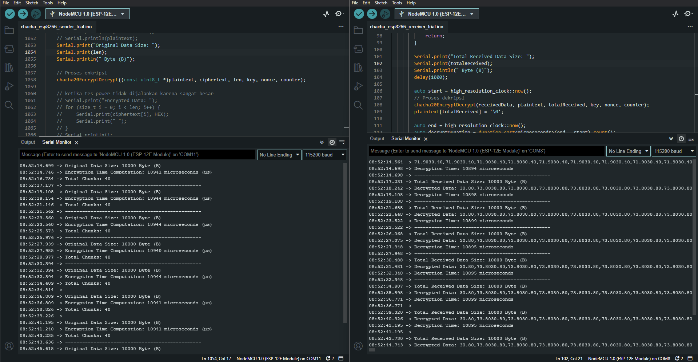

**chacha20 10kb**

**encrypt di 10944 micros**

**decrypt di 108895 micros**

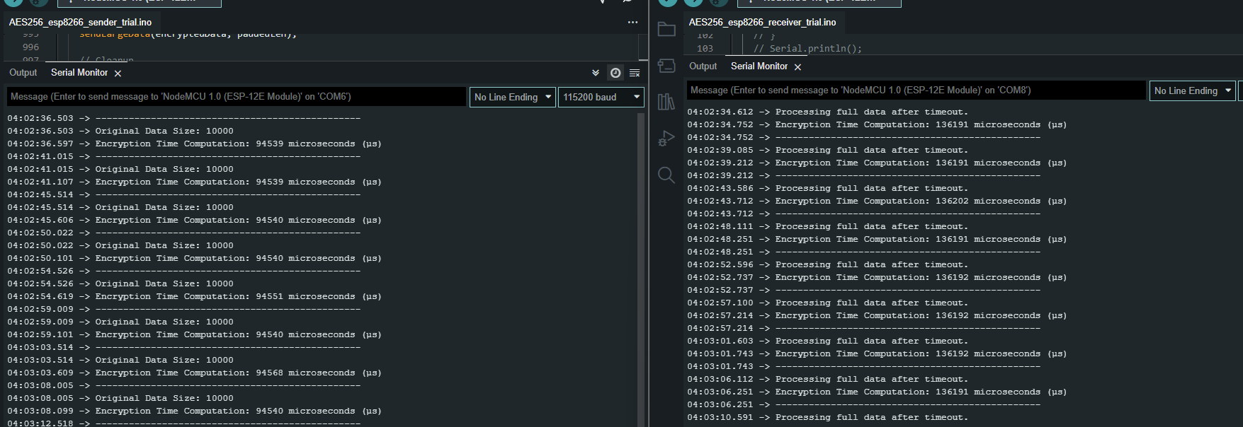

**aes 10kb**

**encrypt di 94540 micros**

**decrypt di 136191 micros**

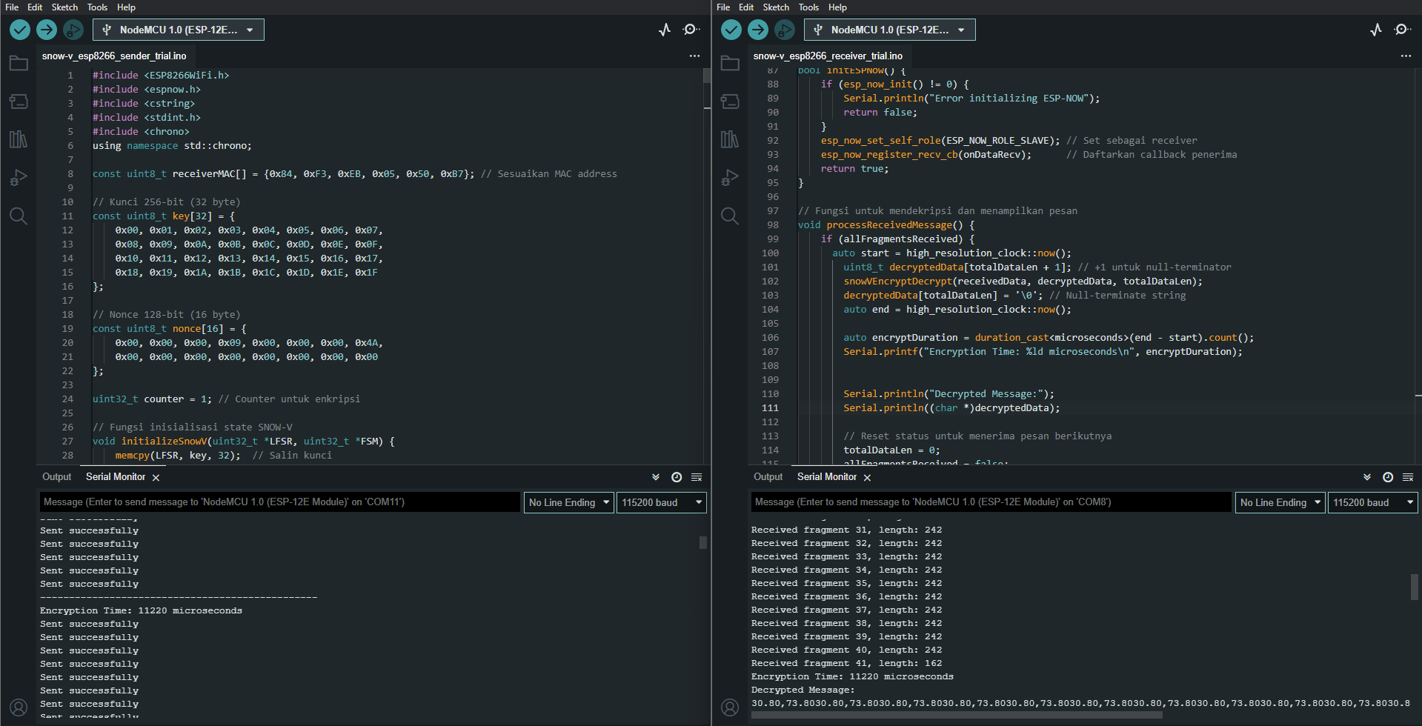

**snow-v 10kb**

**encrypt di 11220 micros**

**decrypt di 11220 micros**